Holtville High School
Restaurant and Food and Beverages Services Department
Hospitality and Tourism/Culinary Arts 1
Culinary Arts 2/Bakery and Pastry Arts
Culinary Arts Lab Rules and Regulations
The HHS Culinary Arts program is a career readiness program. We teach students the guidelines from the National Restaurant Association and the curriculum. Before entering the kitchen laboratory, students will be inspected to be sure they are following safety and sanitation guidelines. Therefore, the following MUST be adhered to when working in the kitchen.
- Must be wearing chef’s jacket and hat. (Those are provided and cleaned for students. (Aprons will be provided to students after they pass inspection).
- Hair must be retrained under hat; hair nets will be provided. Students must provide their own hair ties.
- Student chefs must wear long pants, socks and skid resistant, close-toed shoes. (There will be a storage area provided for students who want/need to leave appropriate clothing, but will be required to take home to clean).
- Fingernails must be short and clean. No false fingernails or nail polish may be worn.
- Infected wounds must be covered by bandages.
- The following jewelry must be taken off: rings (except for plain bands), bracelets (including medical bracelets) and watches. These items can harbor bacteria that can get into food.
- No false eyelashes as they may fall off into food.
- Student chefs may not bring their own food, drinks or gum into kitchen lab. They may have their own drinks during dining time.
Students not able to pass inspection will receive a written assignment for up to 75% of lab grade. 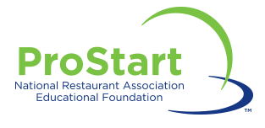
Parent Signature: __________________________ Student Signature: _______________________

